COMPUTER NETWORKS AND TCP/IP LAB

ARP Analysis

ROLL NO:20PW30

NAME: SAI DINESH B

STEP 1:

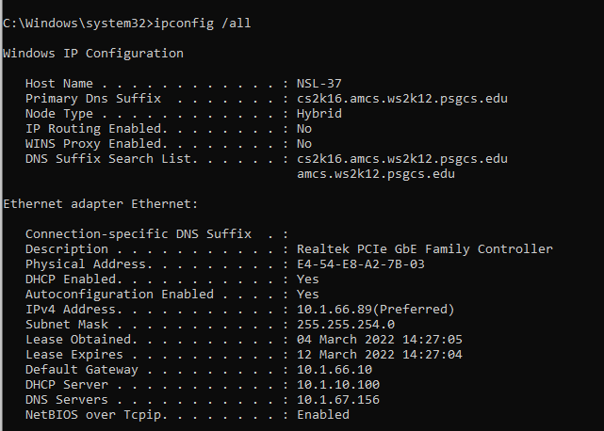

Finding the IP and MAC address of the Host:

IPv4 address:10.1.66.10

MAC address:E4-54-E8-A2-7B-03

DEFAULT GATEWAY:10.1.66.10